4. “SPRING CLEANING” FOR THE SPACE BETWEEN
Adapted from “Making Marriage Simple” by Harville Hendrix & Helen laKelly Hunt
Truth #4: Being Present for Each Other Heals the Past
The Space Between is the invisible space that determines the health of your relationship. You can fill the Between with tension and conflict or you can fill the Between with love and safety.
Here’s an exercise that will help you transform your Between into Sacred Space.
- In the picture below, write your name in one of the small circles and your partner’s name in the other.

- In the large circle at the top, list as many thoughts, feelings, and behaviors as you can that describe the positive things in your Between, the things that are WONDERFUL. These are the things that bring safety, connection, and/ or passion into your relationship, like: respect, love, co-parenting, date nights.

- In the circle at the bottom, list as many thoughts, feelings, and behaviors as you can that describe the negative things in your Between, the things that are CHALLENGING. These are the things that bring doubt, disconnection, and/ or upset into your relationship, like: distrust, criticizing, lack of intimacy, no fun.

- Share with your partner how they contribute to what is wonderful in your relationship. (For example: “The best thing I see you bring to our space is …”) Follow that up with how you contribute to the challenges. (For example: “I feel I contribute to our challenges when I …”)
Explore some ideas together on how you both can increase the wonderful and remove the challenges so that you create safety in the Between, transforming it into Sacred Space.
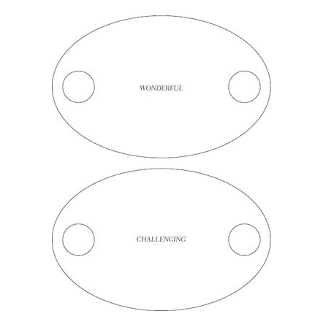

Remember: One of the most beautiful and profound things about a relationship is that we’re called into the role of being each other’s healer. This means NO shame, blame, or criticism in your Between!

